Gantry Robot Kinematic Analysis using Roboanalyzer and CPRog

Abstract

This paper presents an overview of gantry robots, highlighting their design principles, applications, and advancements. Gantry robots, characterized by their overhead-mounted structure and multi-axis movement capability, offer versatility and precision in various industrial and manufacturing tasks. The design considerations encompass aspects such as workspace dimensions, payload capacity, speed, accuracy, and compatibility with automation systems.

The application domains of gantry robots span across industries including automotive, electronics, pharmaceuticals, and logistics, where they facilitate tasks such as material handling, assembly, packaging, and inspection. Their ability to operate in constrained spaces and handle heavy loads makes them indispensable in modern manufacturing environments seeking efficiency and productivity enhancements.

In this paper we will be analyzing the gantry robot’s movements and analyzing its Kinematics using the Software Robo Analyzer and CPRog Programming Environment.

Robot Kinematics

Robot Kinematics studies the relationship between the dimensions and connectivity of kinematic chains and the position, velocity and acceleration of each of the links in the robotic system in order to plan and control movement.

Robot Kinematics are mainly of two types:

1. Forward Kinematics
2. Inverse Kinematics

Introduction to Gantry Robot

A robot gantry is an industrial robot with a robotic arm mounted on an overhead rail system or frame. The gantry structure comprises a series of beams or struts that provide the robot with stability and precision to move along the X, Y, and Z axes. Robot gantries are commonly used in applications where heavy payloads must be lifted and moved over large working areas. The robots can be configured to operate in various environments, including clean rooms, hazardous environments, and other specialized applications.

Gantry Robot Structure

The gantry structure is the framework that supports the robot arm and the end effector module. It consists of two or more parallel beams that move along the X and Y axes and a vertical column that moves along the Z-axis. The structure must be rigid and stable to ensure accuracy and repeatability in the robot's movements.

The gantry structure can be made of different materials, including aluminum, steel, and carbon fiber, depending on the application requirements. The material used must be strong enough to support the weight of the robot arm and the end effector while also being lightweight to reduce the overall weight of the gantry.

Robot Arm

The robot arm is part of the gantry that holds the end effector and moves along the X, Y, and Z axes. The robot arm's design and specifications depend on the application requirements, such as the reach, payload capacity, and speed.

The robot arm can be equipped with different types of end effectors, such as grippers, suction cups, and welding guns, to perform specific tasks.

End Effector

The end effector is the tool or device that is attached to the robot arm to perform a specific task. The end effector can be a gripper, a suction cup, a welding gun, a cutting tool, or any other device that can manipulate the part or material being processed.

The end effector must be designed to match the application requirements, such as the shape and size of the part, the weight, and the material being processed. The end effector's design can also impact the overall accuracy and repeatability of the robot's movements.

Drive System

The drive system consists of motors and actuators that control the movement of the gantry structure and the robot arm. Depending on the application requirements, the drive system can be either hydraulic, pneumatic, or electric.

The drive system's specifications depend on the application requirements, such as speed, torque, and precision. The drive system must also be designed to work with the control system to achieve accurate and precise movements.

Control System

The control system is the brain of the robot gantry, responsible for controlling the movement of the gantry structure and the robot arm.

The control system's software must be programmed to match the application requirements, such as the motion profile, the acceleration and deceleration rates, and the path planning. The control system must also integrate with other sensors and equipment to achieve accurate and precise movements.

Overall, the design and specifications of each component of a robot gantry must be carefully considered to achieve accurate and precise movements, ensuring the gantry's reliability and efficiency in performing its intended task.

Types Of Gantry Robot

There can be multiple types of gantry robots, namely.

Cartesian Gantry

Cartesian gantries, also known as linear robot gantries, are the most commonly used type of robot gantry. They consist of two or more linear axes that move in a straight line along the X, Y, and Z axes. The robot arm is mounted on a carriage that moves along the gantry structure, allowing it to reach different points within the work envelope.

Cartesian gantries are known for their high accuracy and repeatability, making them ideal for applications that require precise positioning. They are often used in Computer Numerical Control (CNC) machining, 3D printing, and pick-and-place operations.

Articulated Gantry

Articulated gantries consist of multiple segments that are connected by joints or links. Each joint can rotate around its axis, giving the robot a greater degree of freedom and flexibility than a Cartesian robot gantry. Articulated gantries are commonly used in applications that require a high level of dexterity, such as pick-and-place applications, welding, and painting.

Articulated gantries can reach any point within their workspace by bending their joints, and they are often used in applications that require complex movements. They are also used in collaborative robots or cobots that can work safely alongside human operators.

Parallel Gantry

Parallel gantries, also known as parallel manipulators or delta robots, consist of a series of parallel links that are connected to a fixed base and a moving platform. The robot arm is mounted on the moving platform, and the links are driven by a series of actuators that control the movement of the platform.

Parallel gantries are known for their high payload capacity and stiffness, making them suitable for heavy-duty applications such as material handling and assembly. They are often used in the food and beverage industry for packaging and palletizing operations, where speed and accuracy are critical

Hybrid Gantry

Hybrid gantries combine the features of two or more gantry system configurations to create a customized solution for specific applications. For example, a hybrid gantry may combine the high accuracy of a cartesian gantry with the flexibility of an articulated gantry, or the high payload capacity of a parallel gantry with the precision of a Cartesian gantry.

Hybrid gantries are often used in applications that require a unique combination of features that cannot be achieved with a single gantry type.

Applications Of Gantry Robot

Gantry Robot is used in various industries like manufacturing, automotive, aerospace, and logistics where there is requirement of high level of precision and repetitive movement. Some Examples are-

Material Handling- Gantry Robot is widely used for transport of goods from one place to another, for example the Gantry Robot can lift a material in a factory from a conveyor belt and coordinate with other Robots to either place it somewhere or use it in some product.

Welding – Industries like aerospace and automotive where precision welding of parts in a repetitive manner is required Gantry Robot does the Job very precisely.

Painting – Any industry that requires the painting of any material can be automated by Gantry Robot the robot automates this process faster and much precisely than humans which also is much efficient.

Introduction to CPRog Software

CPRog is a control and programming environment for robots. The 3D user interface allows a quick start into programming. Due to the modular design different kinematics and motor drivers can be controlled.

According to the user guide of CPRog Software the minimum specifications to run this program is-

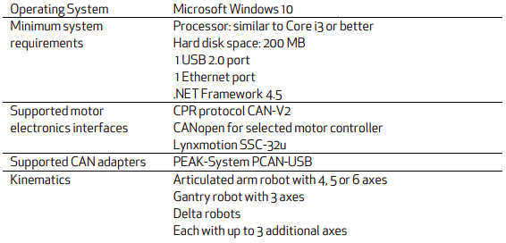

Installation

Once you know about the basic requirements of this software we can start with its installation.

Step 1 – go to <https://cpr-robots.com/robot-control> and click on the [download](https://wiki.cpr-robots.com/index.php/Software_Updates) CPRog option.

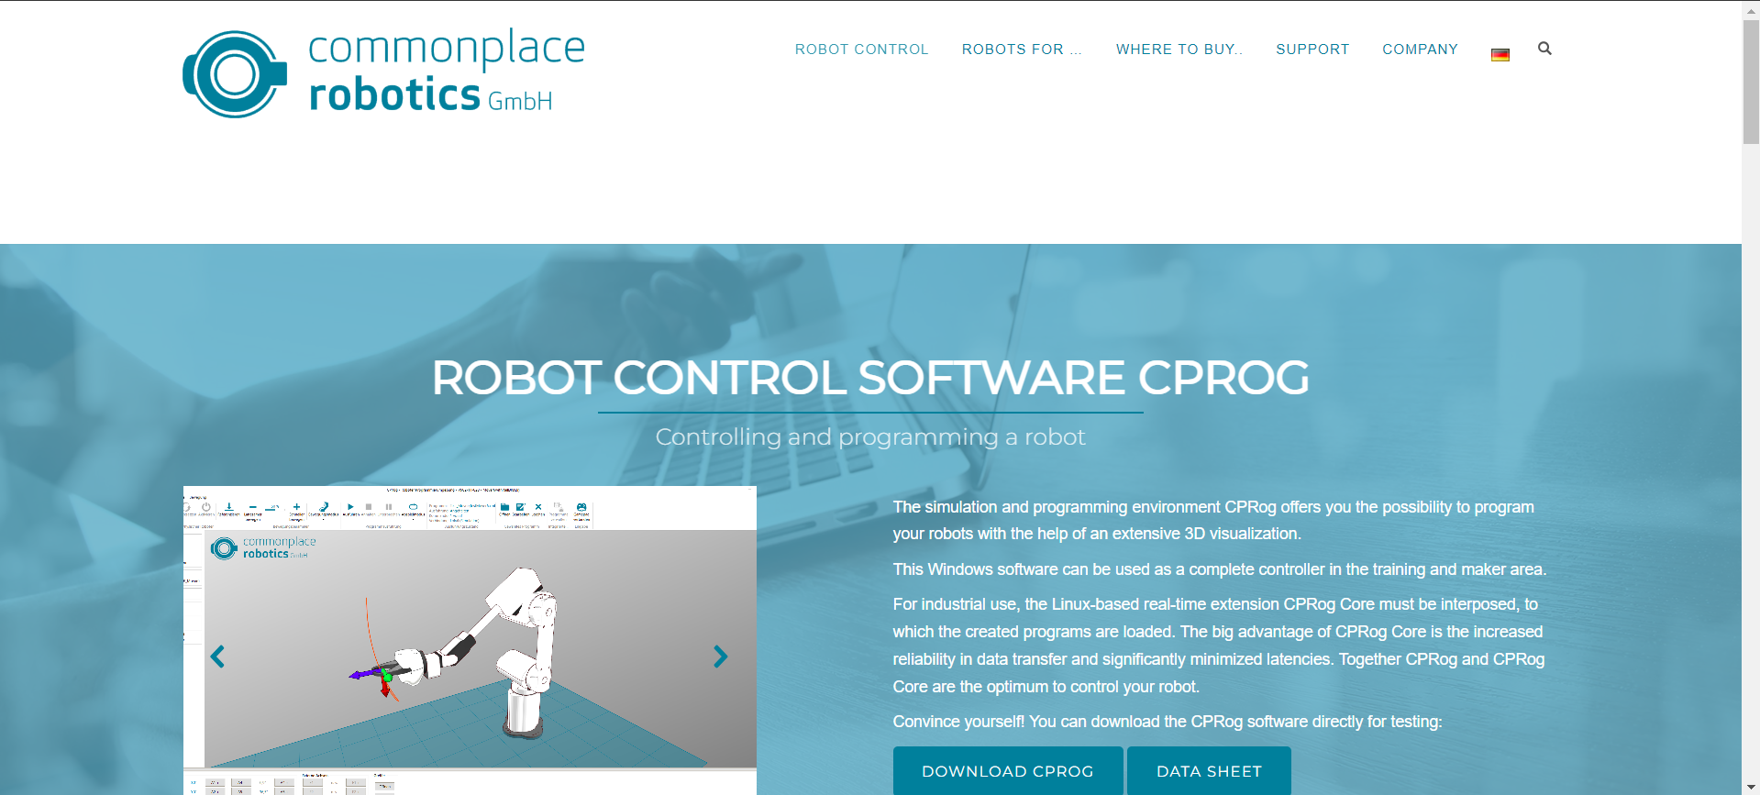

Step 2 – Once you have clicked the download CPRog option you will be redirected to another site which will look like this

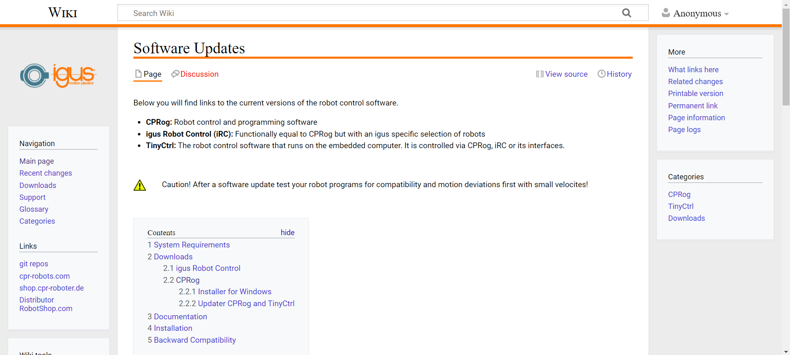

Now scroll down in this site till you see the CPRog section and click the [Version V13-040](https://cpr-robots.com/download/CPRog/Installer_CPRog_V13-040.exe) this will lead to a prompt asking you where to install the installer.

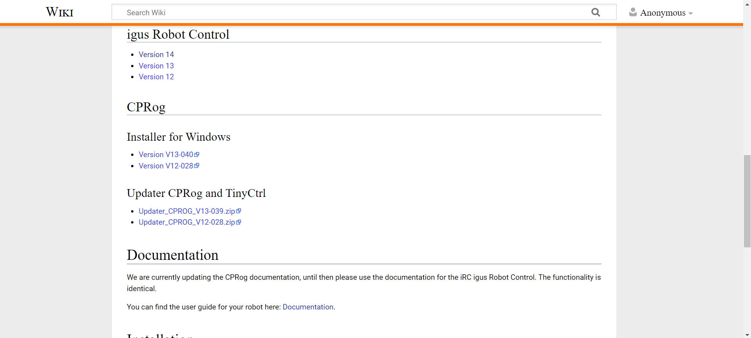

Once you have installed the installer run it and download the Programmer